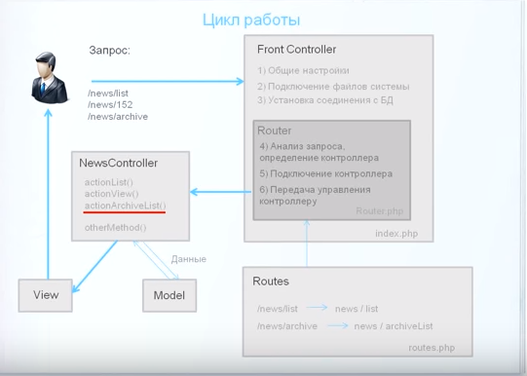

Index.php---> Router.php--->routes.php--->NewsController.php🡪views/news/index.php

🡪views/news/onenews.php